PRACTICE PROGRAMS
Write a C program to perform the following a) Linear search
#include <stdio.h>
int main()
{
int key; int n; int pos;
int arr[]= {1,2,3,4,5,6,7,8,9};
printf("enter element to search:\n");
scanf("%d", &key);
for (int i=0; i<10; i++) {
if (arr[i]==key)
{
n=1;
pos=i+1;
break;
}
else{
n=0;
}
}
if (n==1)
{
printf("key found at %d", pos);
}
else{
printf("not found!");
}
return 0;
}
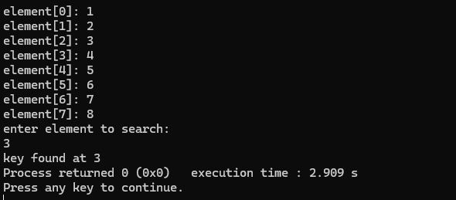

Write a C program to perform the following a) Linear search b) Binary
search.
#include<stdio.h>
void main()
{
int i, low, high, mid, n, key, array[100];
printf("Enter number of elements in the array");
scanf("%d",&n);
printf("Enter the array elements");
for(i = 0; i < n; i++)
scanf("%d",&array[i]);
printf("Enter value to be searched ");
scanf("%d", &key);
low = 0;
high = n - 1;
mid = (low+high)/2;
while (low <= high) {
if(array[mid] < key)
low = mid + 1;
else if (array[mid] == key) {
printf("\n %d found at location %d", key, mid+1);

break;
}
else
high = mid - 1;
mid = (low + high)/2;
}
if(low > high)
printf("Not found! %d isn't present in the list", key);
}
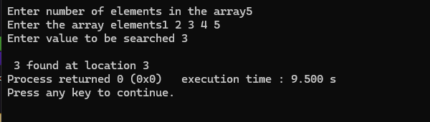

Write a C program to print the smallest number and its position in an
array of size n.
#include<stdio.h>
void main()
{
int n=8;
int min;
int arr[]={13,11,10,9,5,3,2,1};
min = arr[0];
for (int i=0; i<n; i++)
{
if (arr[i]<min)
{
min=arr[i];
}
}
printf("minimum is %d\n", min);
}
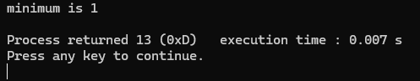

Write a C program to find if there are duplicates in an array.
#include<stdio.h>

int main()
{
int arr1[]={1,5,4,3,7,8,8,2,6};
int n;
printf("array 1: \n");
for (int i=0; i<8; i++)
{
printf("element[%d]: %d\n", i, arr1[i]);
}
for (int i=0; i<8; i++)
{
for (int j=0; j<8; j++)
{
if(i==j)
{
n=1;
}
else
{
n=0;
}
}
}
if (n==1)
{

printf("duplicates found\n");
}
else
{
printf("duplicates not found");
}
}
